OFFICIAL ANNOUNCEMENT

Korea Nazarene University (KNU) has been appointed by Cheonan City to recruit English teachers who team-teach with the Korean teachers at elementary, middle schools and High Schools in Cheonan. KNU is an accredited private University. KNU is looking for teachers to teach at the various schools in Cheonan City.

1. Qualifications
Minimum Requirements:
• Must have a Bachelor’s degree or above in any area
• Citizen of a country where English is the primary language spoken and able to
obtain an E2 visa in Korea
• The ability to effectively and cooperatively work in a team setting
Fully vaccinated for Covid 19

Preferred Requirements:
A bachelor’s degree applicant who has one of the following qualifications
• Education/English Literature/English Language/Linguistics/at least 100 hours of TESOL,TEFL,CELTA
• Teaching certificates from an accredited institution
• Experience with and teaching in the Korean K-12 public education system

2. Employment Period
•one year starting September 1st through August 31st or March 1 through February 28
• Working hours are Monday through Friday; 22hours a week of teaching and shall
Follow the normal work schedule of Korean teachers

3. Benefits
• 2.2million won per month (including lunch and transportation fee)
• Both inbound and outbound airfare supported (for overseas hires and after
successful completion of a 12month contract only)
• Housing provided (on or off campus)
• 4weeks of paid vacation (2weeks in the summer, 2weeks in the winter/during the
school vacation)
• Severance pay (after completion of contract period)
• National Pension Plan - 50% program and 50% individual
• Health Insurance - 50% program and 50% individual
• Program sponsored by Cheonan City Government & Cheonan Education Office

If you are interested in this cross-cultural teaching in S. Korea, please send your
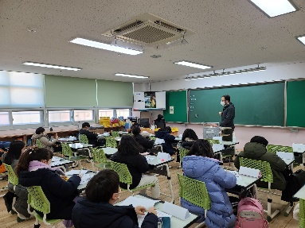
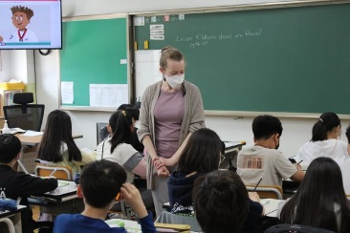
resume with cover letter to pastormom1985@yahoo.com.

